**Eastern Upper Peninsula**

If you have questions about the School Based Services Program, contact:

Andrea Vansloten (906) 632-3373 ext. 5101

**What school districts participate in the School-Based Services program?**

Bay Mills Ojibwe Charter School

Bois Blanc Pines School

Brimley Area Schools

DeTour Area Schools

DeTour Arts & Technology Academy

Engadine Consolidated Schools

Les Cheneaux Community Schools

Pickford Public School

Rudyard Area Schools

Sault Ste. Marie Area Public Schools

St. Ignace Area Schools

Tahquamenon Area Schools

Three Lakes Academy

Whitefish Township Community Schools

**Intermediate School District**

***Medicaid Reimbursement Program***

SCHOOL-BASED SERVICES

*Medicaid Reimbursement*

**Eastern Upper Peninsula** _____ ____________________

**Intermediate School District**

315 Armory Place *Help Us Help Them*

Sault Ste. Marie, MI 49783



Phone: (906) 632-3373

Fax: (906) 632-1125

Website: www.eupschools.org





Rachel Fuerer, Director

Special Education, EUPISD

Adapted from Wayne RESA

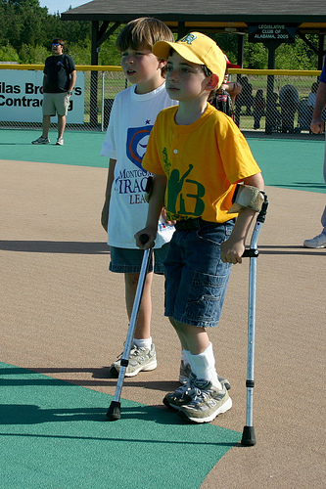

**What is the School-Based Program? Is there a cost to me? How can I help assure my school district**

**receives benefits from the School Based**

Since 1993, the State of Michigan has participated in No – IEP services are provided to students **Services program?**

a Federal program called School Based Services. The while they are at school at NO cost to the

program assists school districts by providing partial parent/guardian. School districts have been participating

reimbursement for medically-related services that since 1993, but recently Federal

are listed on a student’s Individualized Educational **Will it impact my family’s Medicaid benefits?** Regulations changed to require the

Program (IEP) or Individualized Family Service Plan parent/guardian:

(IFSP). Although this partial reimbursement is available The School-Based Services program does NOT

only for students who are Medicaid eligible, services are impact a family’s Medicaid services, funds or - To be fully informed about the School-Based

provided to all students with disabilities regardless of limits. Michigan operates the School-Based Services program.

their Medicaid eligibility status. Services program differently than the Family

Medicaid program. The School-Based Services - To provide consent to release school

The Michigan School Based Services Program is under program does not affect your family’s Medicaid records containing the student’s information

the direction of the Michigan Department of Community benefits in any way. to Michigan Medicaid and billing agencies

Health. for the purpose of participating in the School- Based Services program.

**What type of services for children does the**

**School Based Services program cover?** - To understand that consent is voluntary

and can be revoked.

- Occupational Therapy

- Physical Therapy

- Speech and Language You can help by providing your written

- Orientation & Mobility consent which allows your school district

- Assistive Technology Services to continue to participate in the School

- Psychological/Social Work Based Services program. In the times of

- Evaluations reduced state funding for schools, all

- Developmental Testing reimbursements are extremely

- Nursing important.

- Case Management

- Personal Care

- Special Education Transportation

---*Help Us Help Them---*

*School Based Services*